Image Sampling and Quantisation
Code:
import cv2
import numpy as np

image = cv2.imread("zurafa.jpg", cv2.IMREAD_GRAYSCALE)
cv2.imshow("Original Image", image)
downsampled_image = cv2.resize(image, (image.shape[1] // 2, image.shape[0] // 2), interpolation=cv2.INTER_AREA)
cv2.imshow("Downsampled Image", downsampled_image)

upsampled_image = cv2.resize(downsampled_image, (image.shape[1], image.shape[0]), interpolation=cv2.INTER_LINEAR)
cv2.imshow("Upsampled Image", upsampled_image)
def quantize_image(img, levels):
max_val = 255
step = max_val // levels
quantized_img = (img // step) * step
quantized_img = np.clip(quantized_img, 0, max_val) # Ensure pixel values are within valid range
return quantized_img.astype(np.uint8) # Convert to uint8 for correct display and saving

quantized_image = quantize_image(image, 4)
cv2.imshow("Quantized Image (4 Levels)", quantized_image)
cv2.imwrite("downsampled_example.jpg", downsampled_image)
cv2.imwrite("upsampled_example.jpg", upsampled_image)
cv2.imwrite("quantized_example.jpg", quantized_image)
cv2.waitKey(0)
cv2.destroyAllWindows()

Code Explanation:
- Image Loading:
image = cv2.imread("zurafa.jpg", cv2.IMREAD_GRAYSCALE)
  - Loads an image in grayscale mode.
- Displaying Original Image:
cv2.imshow("Original Image", image)
  - Shows the original grayscale image.
- Downsampling:
downsampled_image = cv2.resize(image, (image.shape[1] // 2, image.shape[0] // 2), interpolation=cv2.INTER_AREA)
  - Resizes the image to half of its original size, reducing its resolution.
- Upsampling:
upsampled_image = cv2.resize(downsampled_image, (image.shape[1], image.shape[0]), interpolation=cv2.INTER_LINEAR)
  - Resizes the downsampled image back to its original dimensions using linear interpolation.
- Quantizing Image:
def quantize_image(img, levels):
max_val = 255
step = max_val // levels
quantized_img = (img // step) * step
quantized_img = np.clip(quantized_img, 0, max_val)
return quantized_img.astype(np.uint8)
  - Divides the pixel values into specified levels (in this case, 4 levels) and then maps the values to these levels.
  - np.clip() ensures the values stay within the valid range [0, 255].
- Saving Images:
cv2.imwrite("downsampled_example.jpg", downsampled_image)
cv2.imwrite("upsampled_example.jpg", upsampled_image)
cv2.imwrite("quantized_example.jpg", quantized_image)
  - Saves the processed images: downsampled, upsampled, and quantized.
- Closing Windows:
cv2.waitKey(0)
cv2.destroyAllWindows()
  - Waits for a key press to close the image windows.

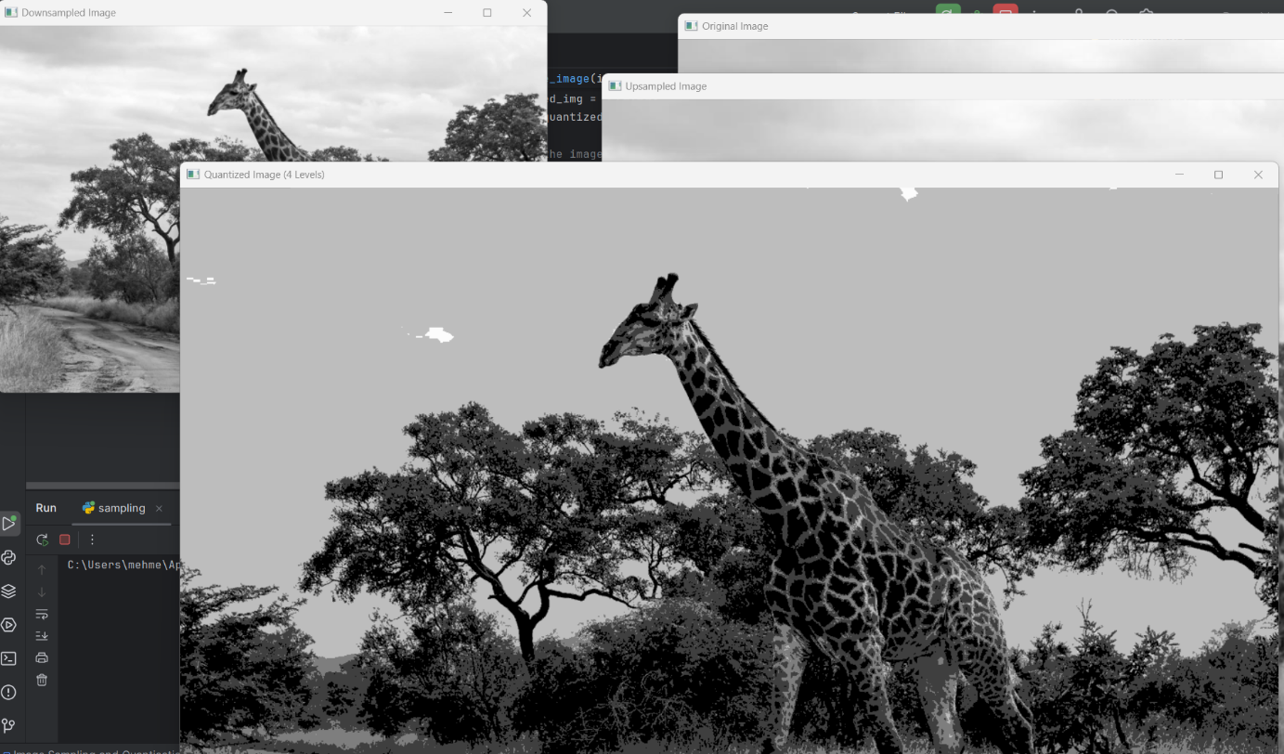

Report:
Objective: The script performs three image processing operations: downsampling, upsampling, and quantization.
- Downsampling: The image is resized to half of its original dimensions to reduce its resolution.
- Upsampling: The downsampled image is resized back to the original size, using linear interpolation to estimate missing pixel values.
- Quantization: The pixel values are reduced to 4 discrete levels, which simplifies the image by reducing its color depth.
Output:
- Three processed images: one downsampled, one upsampled, and one quantized.
- These images are saved to disk for further use.

